**Topics: Normal distribution, Functions of Random Variables**

1. The time required for servicing transmissions is normally distributed with *μ* = 45 minutes and *σ* = 8 minutes. The service manager plans to have work begin on the transmission of a customer’s car 10 minutes after the car is dropped off and the customer is told that the car will be ready within 1 hour from drop-off. What is the probability that the service manager cannot meet his commitment?
2. 0.3875
3. 0.2676
4. 0.5
5. 0.6987
6. **Knowledge from :** [**https://towardsdatascience.com/exploring-normal-distribution-with-jupyter-notebook-3645ec2d83f8**](https://towardsdatascience.com/exploring-normal-distribution-with-jupyter-notebook-3645ec2d83f8)

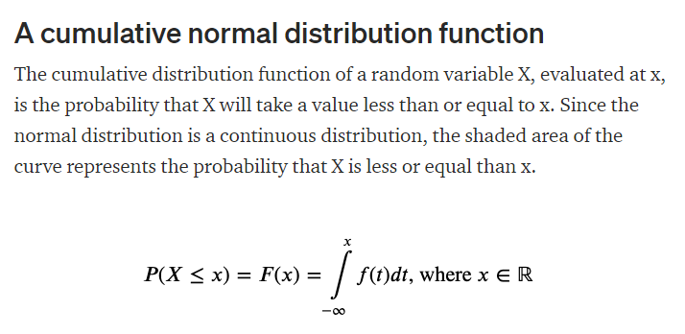

Mean = 45, SD=8.

If 10 min is readily consumed, then remaining time is 50 min.

Probability of X>50 is the answer then

P(X>50) = 1 – P(X<=50)

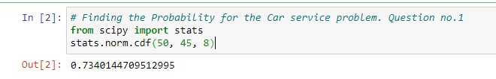

So P(X>50) = 1 – 0.73401 = 0.2676

1. The current age (in years) of 400 clerical employees at an insurance claims processing center is normally distributed with mean *μ* = 38 and Standard deviation *σ* =6. For each statement below, please specify True/False. If false, briefly explain why.
2. More employees at the processing center are older than 44 than between 38 and 44.

Answer) x=44, mean = 38, SD=6

P(X>44) = 1 – P(X<=44)

From notebook,



P(X>44) = 1 – 0.841344 = 0.158656

P(38<X<44) = P(X<44) – P(X<38)

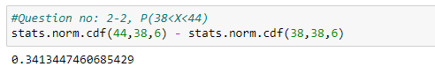

Based on the above probability values, we can say employees aged more than

44 Are higher than the ones aged between 38 and 44.

1. A training program for employees under the age of 30 at the center would be expected to attract about 36 employees.

Ans) P(X<=30)

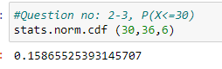

Probability = 0.159 = 0.16

Expected employees = 0.16 * 400 = 64

Hence atleast 36 employees can be expected.

1. If *X1* ~ *N*(μ, σ2) and *X*2 ~ *N*(μ, σ2) are *iid* normal random variables, then what is the difference between 2 *X*1 and *X*1 + *X*2? Discuss both their distributions and parameters.

Answer)

IID = Independent and identically distributed normal random variables.

|  |
| --- |
| As we know that if X∼N(µ1, σ1^2 ), and Y∼ N(µ2, σ2^2 ) are two independent random variables then X+Y∼N(µ1+µ2,σ1^2+σ2^2) , and X−Y∼N(µ1−µ2,σ1^2+σ2^2) . |
|  | Similarly if Z = aX + bY , where X and Y are as defined above, i.e Z is linear combination of X and Y , then Z ∼ N(aµ1 + bµ2, a^2σ1^2 + b^2σ2^2 ). |
|  | Therefore in the question |
|  | 2X1~ N(2 u,4 σ^2) and |
|  | X1+X2 ~ N(µ + µ, σ^2 + σ^2 ) ~ N(2 u, 2σ^2 ) |
|  | 2X1-(X1+X2) = N( 4µ,6 σ^2) |

1. Let X ~ N(100, 202). Find two values, *a* and *b*, symmetric about the mean, such that the probability of the random variable taking a value between them is 0.99.
2. 90.5, 105.9
3. 80.2, 119.8
4. 22, 78
5. 48.5, 151.5
6. 90.1, 109.9

Answer)

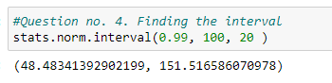

1. Consider a company that has two different divisions. The annual profits from the two divisions are independent and have distributions Profit1 ~ N(5, 32) and Profit2 ~ N(7, 42) respectively. Both the profits are in $ Million. Answer the following questions about the total profit of the company in Rupees. Assume that $1 = Rs. 45
2. Specify a Rupee range (centered on the mean) such that it contains 95% probability for the annual profit of the company.

Answer) X = N(5+7, 3^2 + 4^2) = N(12, 5^2)

So Mean = 12, SD = 5 and p=0.95

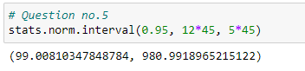

99 Millions rupees to 981 Millions rupees is the range where there is a probability of 95%

1. Specify the 5th percentile of profit (in Rupees) for the company

Answer)

Finding the 5th percentile, we need to know the z value.

For 5% of the profit, z score for 0.05 is -1.64 from the Z table.

X= Mean + z*SD = 540+(-1.64 )*5 = 531.8 million rupees

1. Which of the two divisions has a larger probability of making a loss in a given year?

Answer)

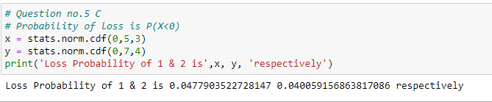

Division 1 has more probability to have loss